P.G. & RESEARCH DEPARTMENT OF MICROBIOLOGY
JAMAL MOHAMED COLLEGE (Autonomous)
Accredited A++ Grade by NAAC (4th Cycle) with CGPA 3.69 out of 4.0
(Affiliated to Bharathidasan University)
TIRUCHIRAPPALLI – 620 020.
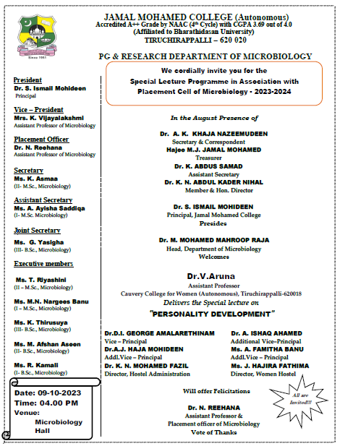

P.G. &RESEARCH DEPARTMENT OF MICROBIOLOGY
JAMAL MOHAMED COLLEGE (Autonomous)
Accredited A++ Grade by NAAC (4th Cycle) with CGPA 3.69 out of 4.0
(Affiliated to Bharathidasan University)
TIRUCHIRAPPALLI – 620 020.

Special Lecture Programme in Association with
Placement Cell of Microbiology 2023-2024

The Guest lecture programme of Microbiology Placement Cell for the academic year 2023 – 2024 was held on 24.07.2023 at 4:00 p.m. in Microbiology Department, Jamal Mohamed College, Tiruchirappalli-20. The programme was started with Qirath. Dr.M.Mohamed Mahroop Raja, Head of Microbiology, welcomed the gathering and honoured the resource person Dr. V. Aruna, Assistant Professor, Cauvery College for Women (Autonomous), Tiruchirappalli-620018. A.K.Afrin of I M.Sc., Microbiology introduced the chief guest. The special invitee Dr.V.Aruna has delivered the lecture on the topic “PERSONALITY DEVELOPMENT”. She focused on the importance of key responsibilities to develop student’s personality as it is a continuous journey of self-discovery, growth and adaptation. Madam also shared her views on the ability to adjust to new circumstances and learn from change. The lecture was really useful for the students. The vote of thanks was proposed by Dr.N.Reehana, Microbiology department Placement officer. Totally 50 students were participated from the Microbiology department. This program was featured with a wide knowledge of sharing the expertise in building positive relationships to a fulfill life.

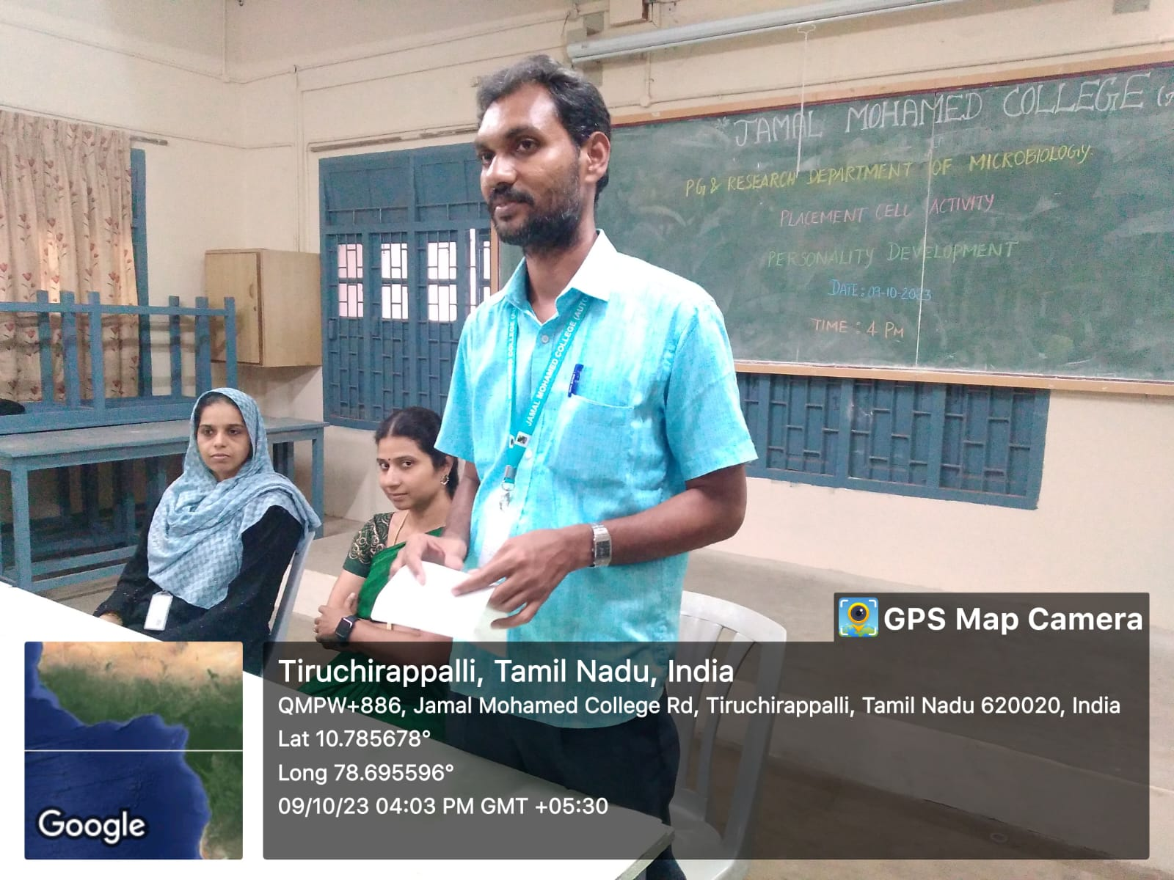

Dr. M.Mohamed Mahroop Raja, Head of Microbiology welcomed the gathering

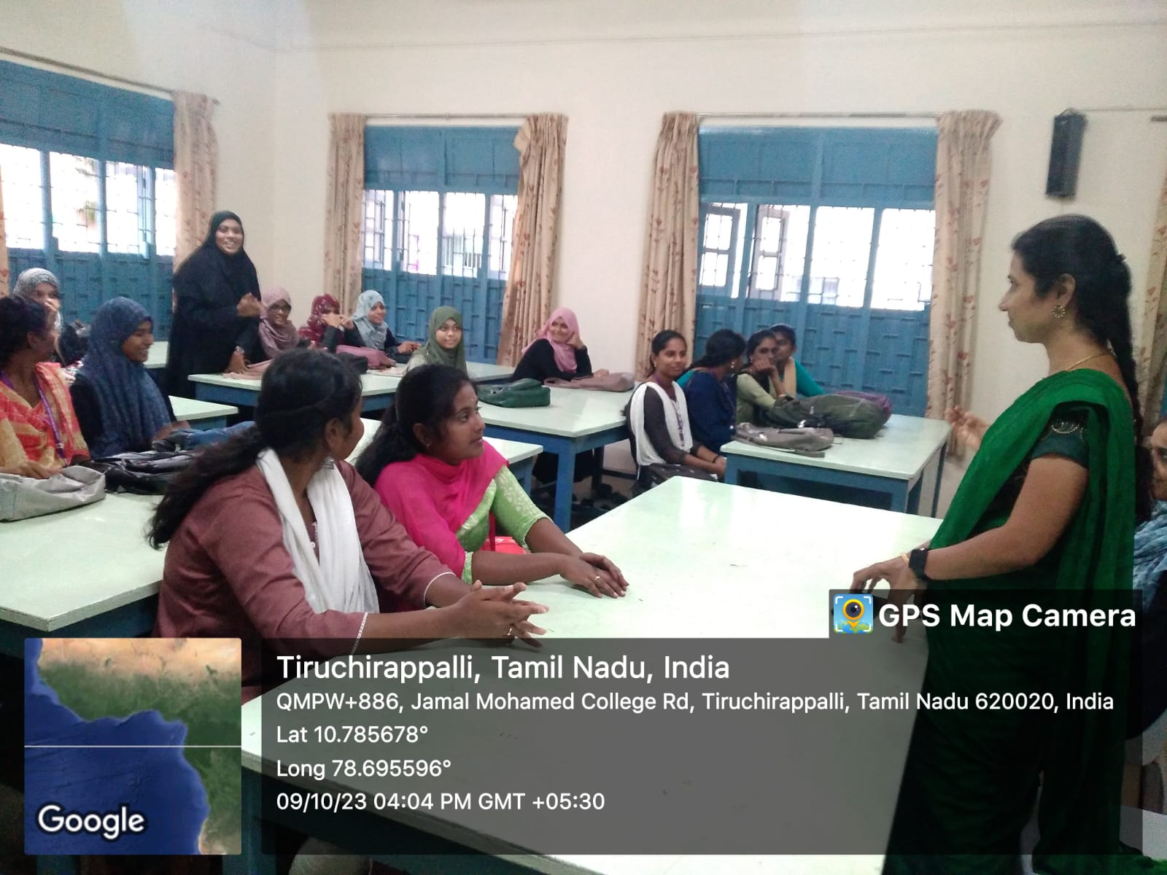

Dr.V.Aruna has delivered the lecture on the topic “PERSONALITY DEVELOPMENT”

